How to do nhibernate mapping demo

Step1: Create tables with primary key, identity, [seed]

(1) Script:

use Business

create table Customer(

CustomerId int primary key identity(1, 1),

FirstName nvarchar(50),

LastName nvarchar(50)

);

create table [Order](

OrderId int primary key identity,

[Version] int,

OrderDate smalldatetime,

CustomerId int foreign key references Customer(CustomerId)

);

create table Product(

ProductId int primary key identity,

[Version] int,

Name nvarchar(100),

Cost int

);

create table OrderProduct(

OrderId int not null foreign key references [Order](OrderId),

ProductId int not null foreign key references Product(ProductId),

primary key (OrderId, ProductId)

);

use Business

insert Customer values('Zhanfei', 'Xiao');

insert Customer values('Ruijie', 'Huang');

insert Customer values('Zhanfei', 'Xiao');

(2) Relationship of tables:

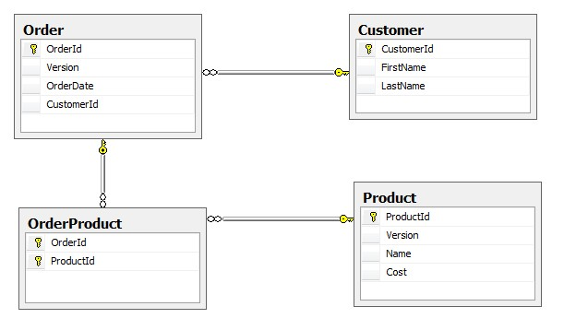

Step2: Create entities, including Customer, Order, Product and OrderProduct.

Step3: Create entities and tables mapping, named “*.hbm.xml”, such as:

<?xml version="1.0" encoding="utf-8" ?>

<hibernate-mapping xmlns="urn:nhibernate-mapping-2.2"

assembly="Domain"

namespace="Domain.Entities">

<class name ="Customer">

<id name="CustomerId">

<generator class ="native"/>

</id>

<property name ="FirstName"/>

<property name ="LastName"/>

</class>

</hibernate-mapping>

Then right click *.hbm.xml -> properties -> set Build Action to “Embedded Resource” -> set copy to output directory to “Copy always”

Step4: Create project and database mapping, named “hibernate.cfg.xml”, such as

<?xml version="1.0" encoding="utf-8"?>

<hibernate-configuration xmlns="urn:nhibernate-configuration-2.2" >

<session-factory name="NHibernate.Test">

<property name="connection.driver_class">NHibernate.Driver.SqlClientDriver</property>

<property name="connection.connection_string">

Data Source=.\SQLEXPRESS;Initial Catalog=Business;

Integrated Security=True;

</property>

<property name="show_sql">false</property>

<property name="dialect">NHibernate.Dialect.MsSql2008Dialect</property>

<mapping assembly ="Domain"/>

</session-factory>

</hibernate-configuration>

Step5: Create session with session factory:

ISessionFactory SessionFactory= (new Configuration()).Configure().BuildSessionFactory();

ISession session = SessionFactory.OpenSession();

Step6: Create test methods and realization methods.